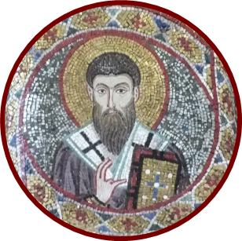
15th International Colloquium on Gregory of Nyssa
6th – 9th September 2022, Exeter

Registration details:-
Please return to:
gregoryofnyssacolloquium@gmail.com

☐ I confirm that I have booked and paid for conference attendance through the on-line form.
Your name as you would like it to appear on your conference badge:

Your location as you would like it to appear on your conference badge: (please keep this brief: e.g. Buenos Aires, Paris, Exeter)

Your email address:

Our use of your information.
We will only store your contact details (email address) for the purposes of organising this conference, unless you let us know below:-
Please select:
☐ I do not wish my email address to be printed in the conference programme.
☐ I do wish my email address to be printed in the conference programme.
☐ Please keep me informed about future Gregory of Nyssa colloquia.

Accessibility: all conference spaces are wheel-chair accessible. Please use the space below/overleaf to tell us if you have any other requests regarding your access to the conference sessions (e.g. requests concerning visual materials or audibility). Thank you!

