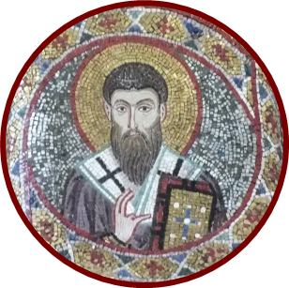
15th International Colloquium on Gregory of Nyssa
6th – 9th September 2022, Exeter

Registration details:-
Please return to:
gregoryofnyssacolloquium@gmail.com
Your name as you would like it to appear on your conference badge:

Your location as you would like it to appear on your conference badge: (please keep this brief: e.g. Buenos Aires, Paris, Exeter)

☐ I would like to apply for a graduate bursary.
- These bursaries will give successful applicants a reduction of up to £150 from the costs of the conference. (We can only take this off sums which would otherwise be payable to the University of Exeter (i.e. registration fee, accommodation in Holland Hall, evening meals on campus). We regret that we cannot pay money towards your travel. The bursary is available for students currently studying for a PhD or research Masters degree (or who have recently graduated and is not yet in paid academic employment).
- If you are successful, we will advise you how to book in a way which will allow you to claim your discount. Thank you.
- Research degree programme
- University
- Supervisor (we do not require a reference: please just provide the name of one member of your supervisory team)

Your email address:

FORM CONTINUED OVERLEAF

Our use of your information.
We will only store your contact details (email address) for the purposes of organising this conference, unless you let us know below:-
Please select:
☐ I do not wish my email address to be printed in the conference programme.
☐ I do wish my email address to be printed in the conference programme.
☐ Please keep me informed about future Gregory of Nyssa colloquia.

Accessibility: all conference spaces are wheel-chair accessible. Please use the space below/overleaf to tell us if you have any other requests regarding your access to the conference sessions (e.g. requests concerning visual materials or audibility). Thank you!

We acknowledge with gratitude the generous gift from the Posbury St Francis Trust which has made these student bursaries possible.

